Creating and Interpreting a Pair Plot

1. Use sns.pairplot() in the provided Jupyter Notebook
2. Explore the relationships between features in a dataframe
3. Report back on your findings
4. **Specifically, in your post, share what relationships you uncovered using the pairplot on the data**
5. You can report on either the Penguin dataset OR the cars dataset.
6. After making your post, review the plots and explanations posted by your peers.

The scatter plot is used to display the relationship between variables (correlation matrix). Let’s see the scatter plot of ‘bill_length_mm’ vs ‘bill_depth_mm’, ‘flipper_length_mm’ and ‘body_mass_g’ by penguin species.

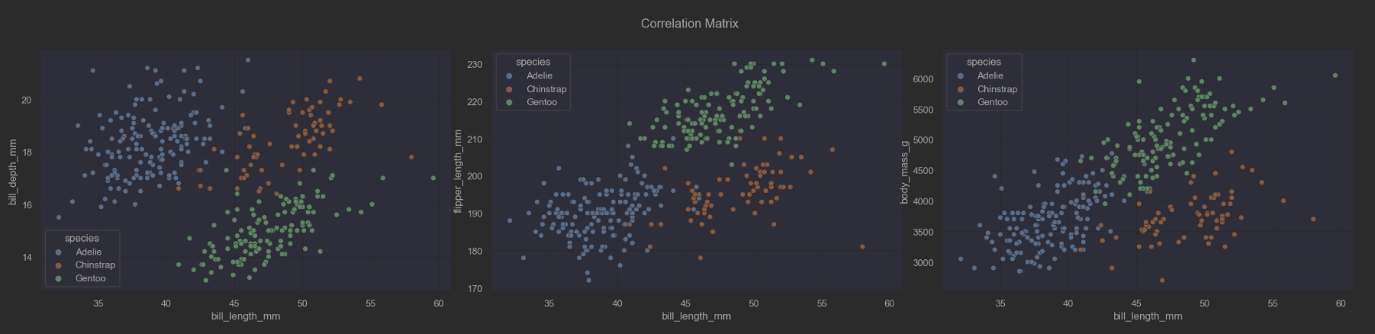

From the scatter plot, you can see a cluster or a group pattern, how the species differ from each other.

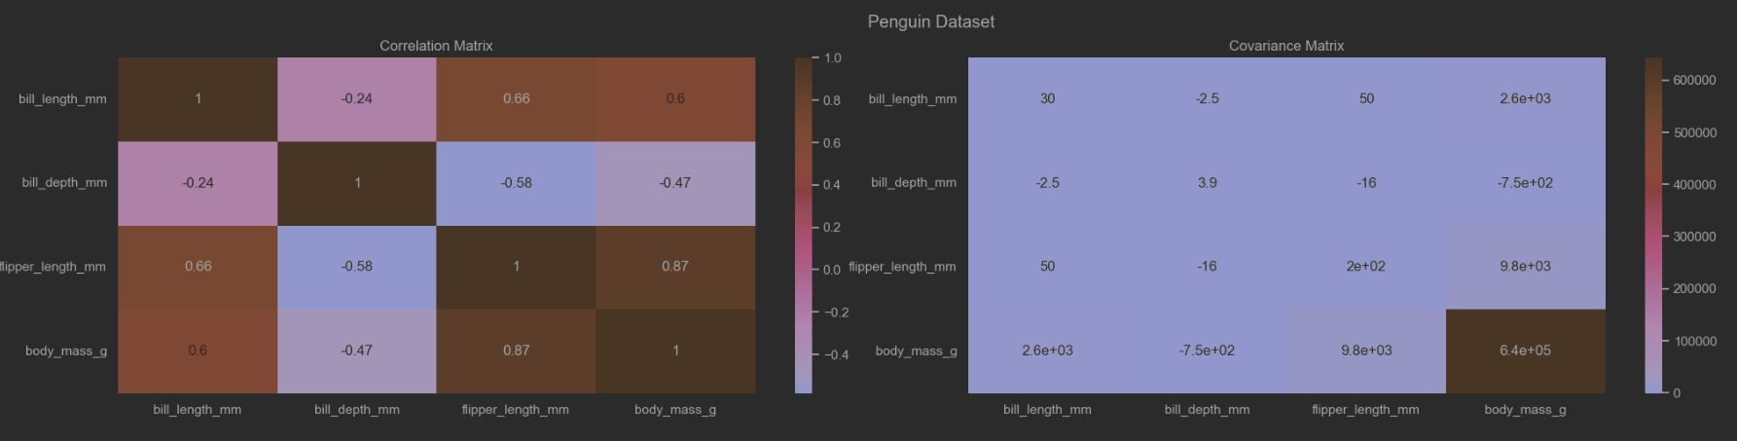

From the Heatmap plot, the correlation and covariance matrix can be visualized to colour according to the strength of associations.

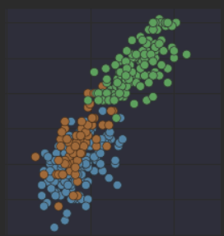

The two feature which have the strongest positive corelation of 0.87 are 'body_mass_g' and 'flipper_length_mm’, also that positive relationship can be confirmed by the covariance matrix with value of 6.4(m). A positive covariance means that both variables (features) tend to be high or low at the same time. As body mass increases, flipper length increases

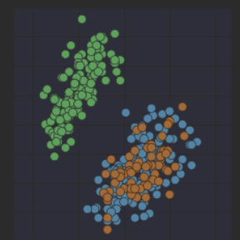

The weakest relationship is observed between ‘body_mass_g’ and ‘bill_depth_mm’ with correlation of -0.47 and covariance of -7.5(m). A negative covariance means that when one variable is high, the other tends to be low. As body mass increases, bill depth decreases.

The features which have the strongest positive corelation of 0.87 are 'body_mass_g' and 'flipper_length_mm’, also that positive relationship can be confirmed by the covariance matrix with value of 6.4(m). As body mass increases, flipper length increases.

Another case of strong relationship is between 'bill_length_mm' and  'flipper_length_mm' features withh positive corelation of 0.66 and positive covariance of 50. As bill length increases, flipper length increases.

From the Hystogram plot of ‘body_mass_g’ feature , you can see the Gentoo species are with a larger body